- Continuous Numeric Data
ID | Age | Height | Weight
1 | 25 | 175 | 70
2 | 30 | 180 | 80
3 | 28 | 170 | 65
4 | 35 | 165 | 75
5 | 40 | 185 | 90
Create a scatter plot between Age and Weight.
Generate a histogram of Height.
Plot a line chart showing changes in Weight over IDs.
Create a box plot of Age.
Create a density plot of Height.
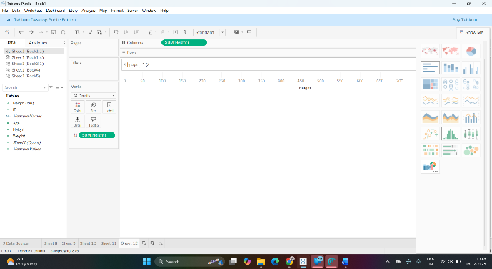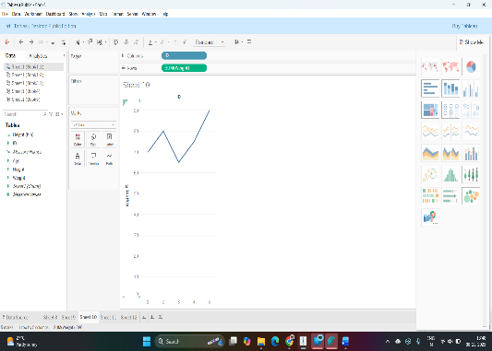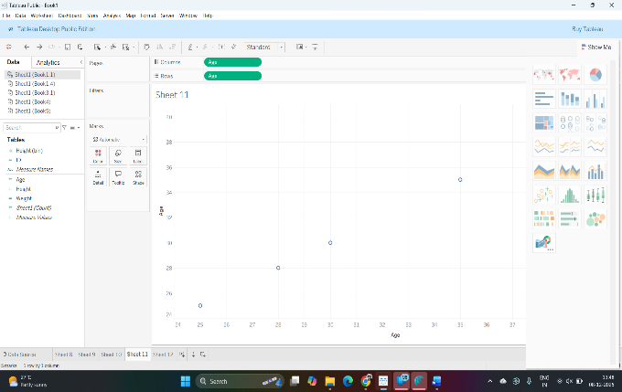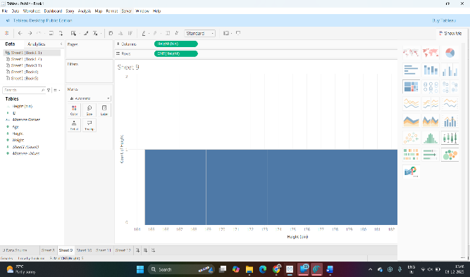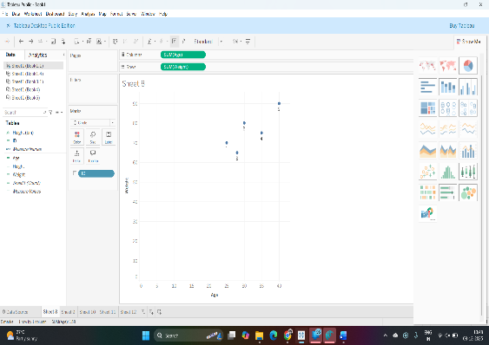
- Categorical Data
ID | Gender | Education | Occupation
1 | Male | Graduate | Engineer
2 | Female | Undergrad | Teacher
3 | Male | High School | Doctor
4 | Female | Graduate | Lawyer
5 | Male | Undergrad | Artist
Create a bar plot showing the count of each Gender.
Plot a pie chart representing the distribution of Education levels.
Create a stacked bar plot showing the count of each Occupation by Gender.
Generate a mosaic plot to visualize the association between Education and Occupation. Create a grouped bar plot showing counts of Gender across different Education levels.
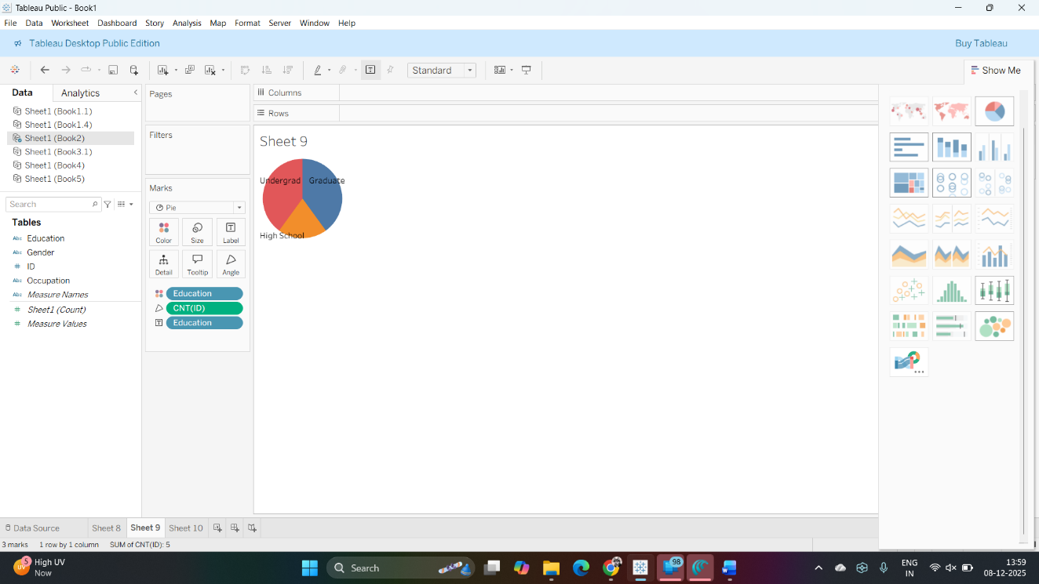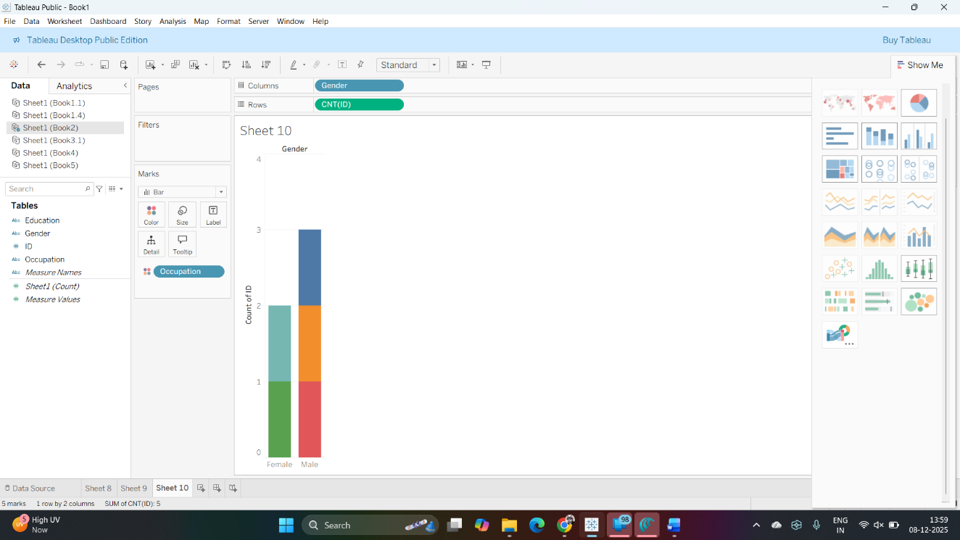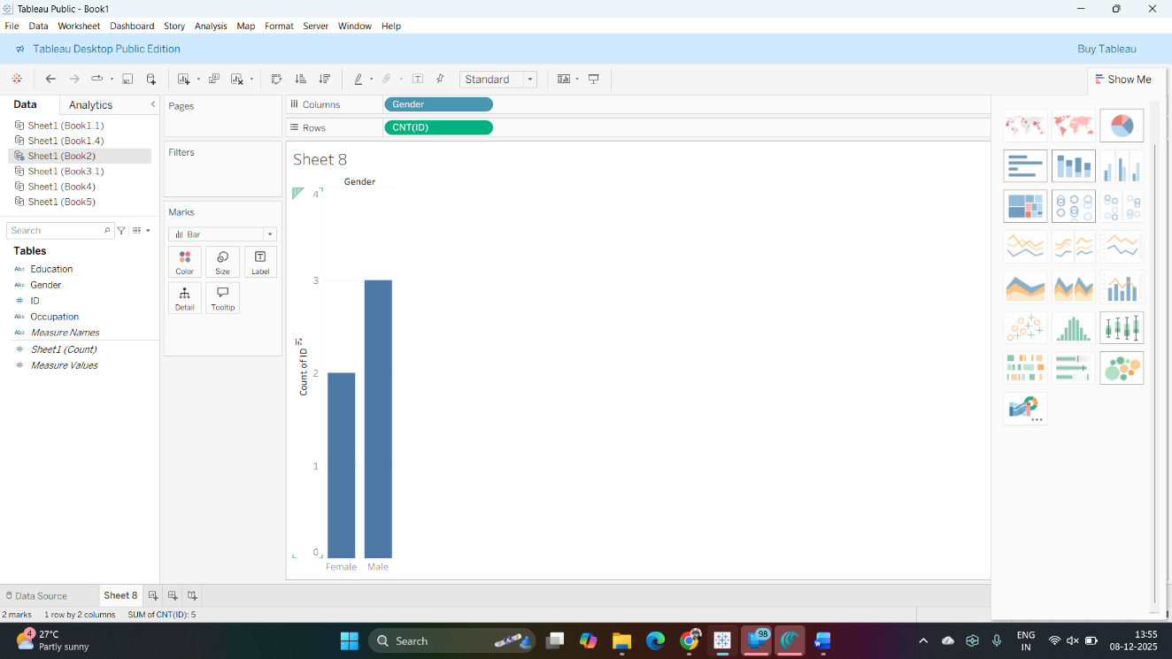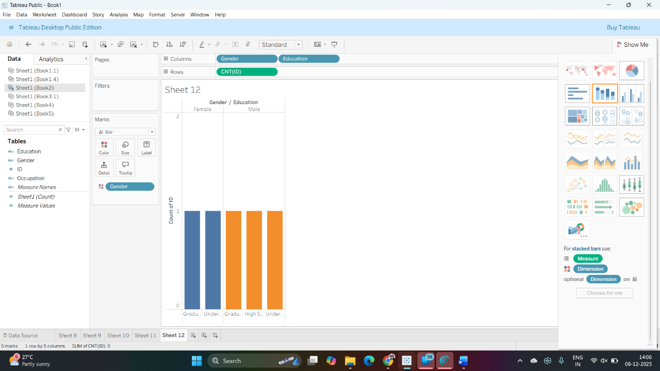
- Time Series Data
Date | Sales
2023-01-01 | 100
2023-02-01 | 120
2023-03-01 | 150
2023-04-01 | 130
2023-05-01 | 140
Create a line plot of Sales over time.
Generate a bar plot showing monthly average Sales. Plot a seasonal decomposition of Sales.
Create a lag plot to analyze autocorrelation in Sales.
Generate a time series plot with a smoothed line of Sales.
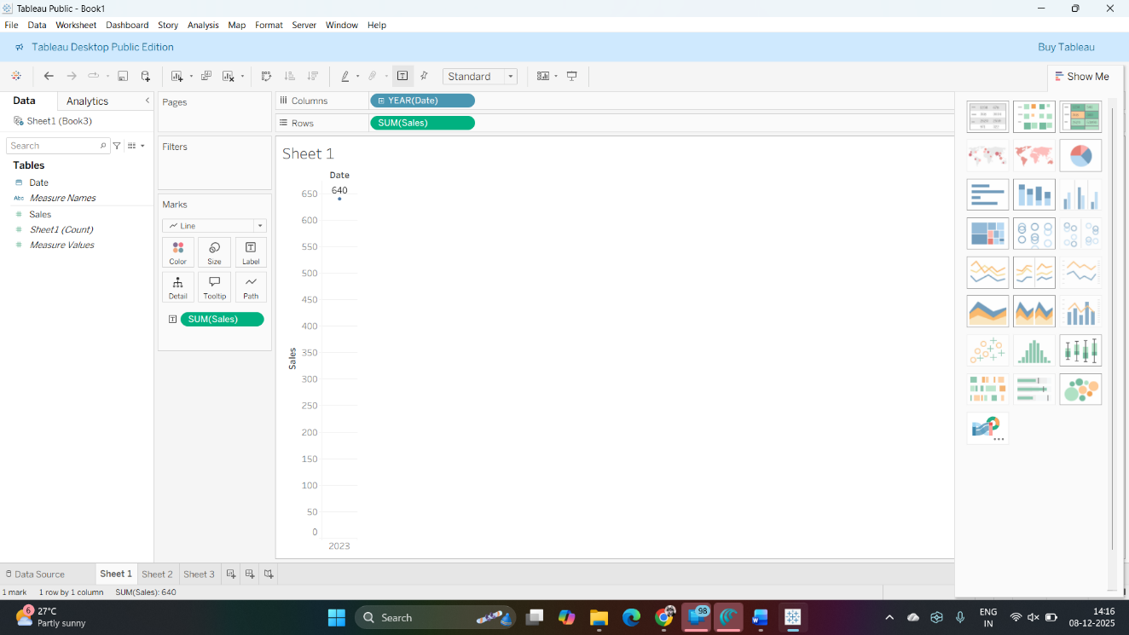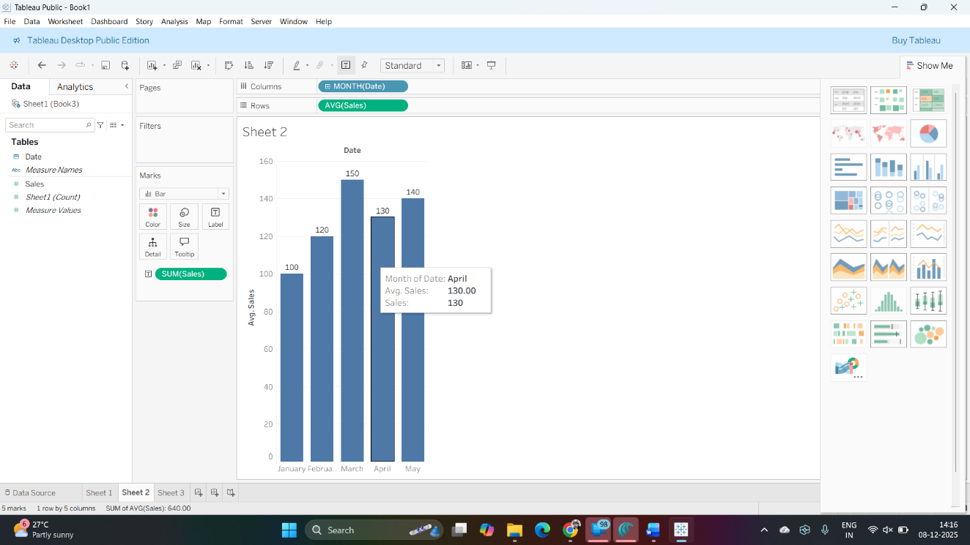

- Geospatial Data
City | Latitude | Longitude | Population
New York | 40.7128 | -74.0060 | 8398748
Los Angeles | 34.0522 | -118.2437 | 3990456
Chicago | 41.8781 | -87.6298 | 2705994
Houston | 29.7604 | -95.3698 | 2325502
Phoenix | 33.4484 | -112.0740 | 1660272
Create a scatter plot of cities on a map based on Latitude and Longitude.
Generate a bubble map where the bubble size represents the Population.
Plot a choropleth map of Population by city.
Create a bar plot showing the top 5 cities by Population.
Generate a heatmap showing the density of cities based on Population.
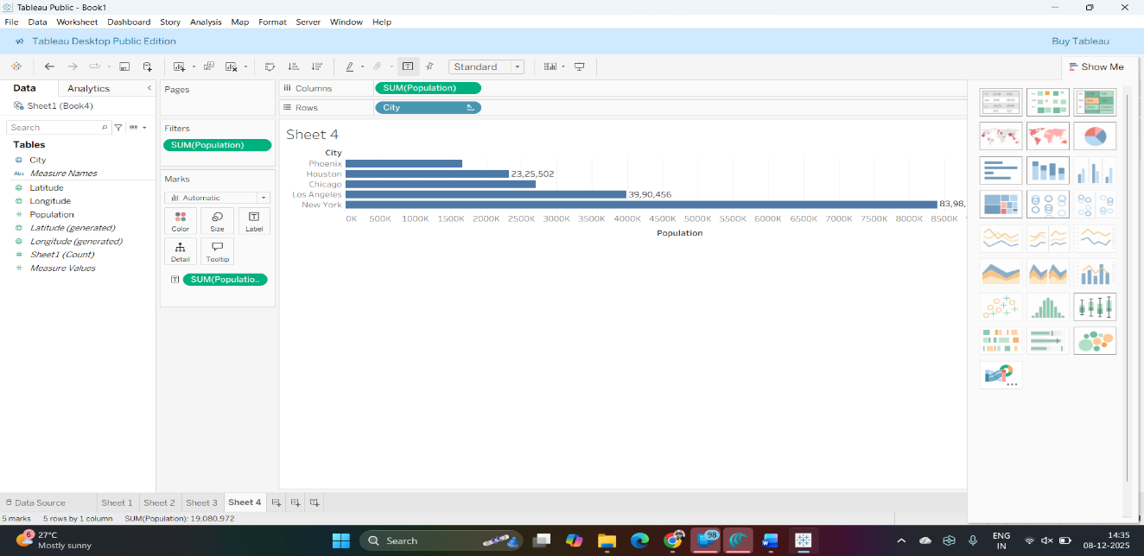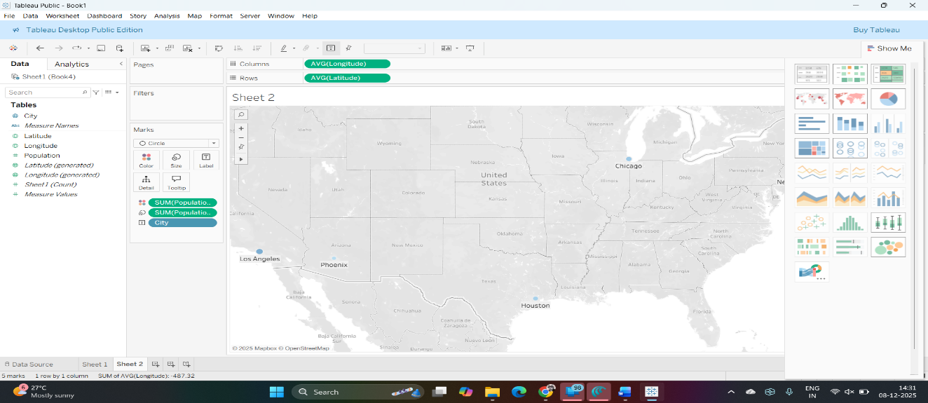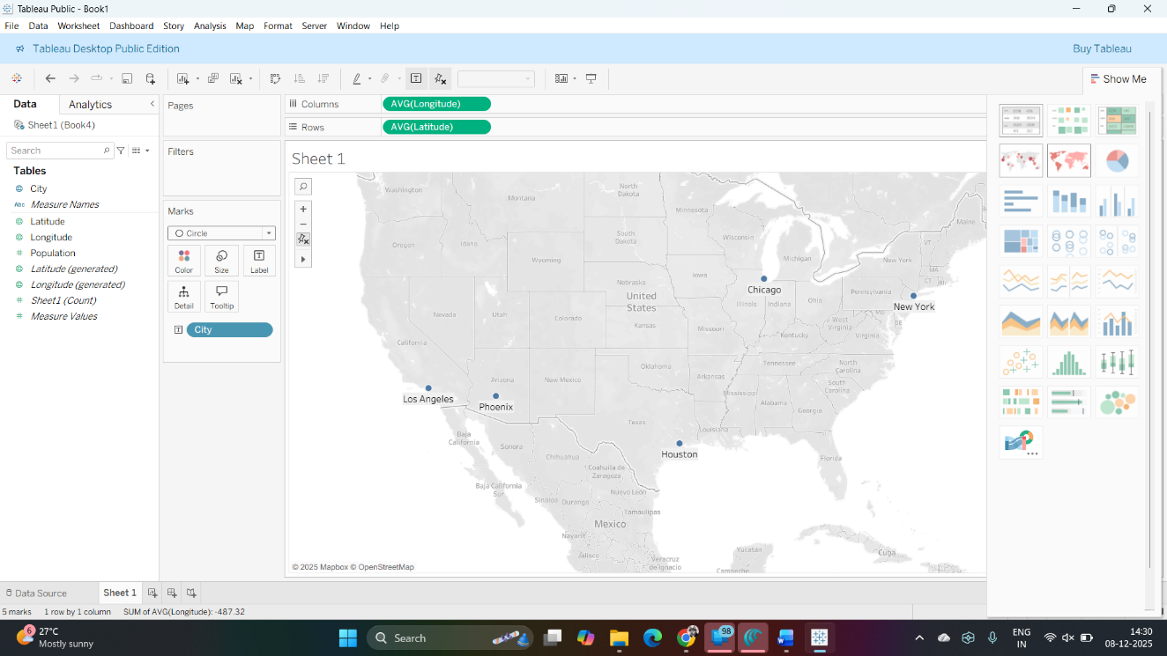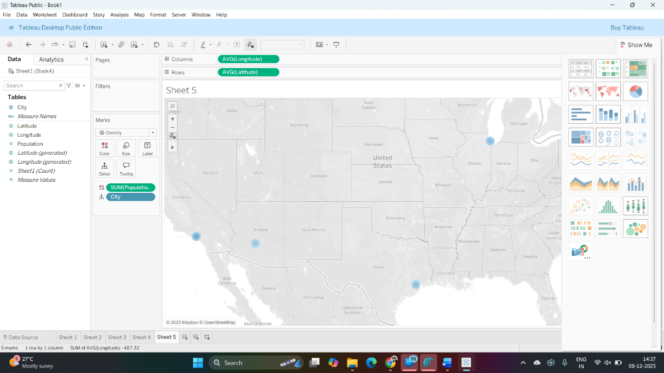

- Multivariate Data
ID | X1 | X2 | X3
1 | 5 | 10 | 15
2 | 7 | 12 | 14
3 | 6 | 11 | 13
4 | 8 | 9 | 16
5 | 4 | 13 | 17
Create a pairwise scatter plot matrix of X1, X2, X3, and X4.
Generate a 3D scatter plot of X1, X2, and X3.
Plot a parallel coordinates plot of X1, X2, X3, and X4.
Create a radar chart to compare values of X1, X2, X3, and X4 for ID 1.
Generate a heatmap showing correlations between X1, X2, X3, and X4.
